1. Design the above database with following table by applying primary key and foreign key.

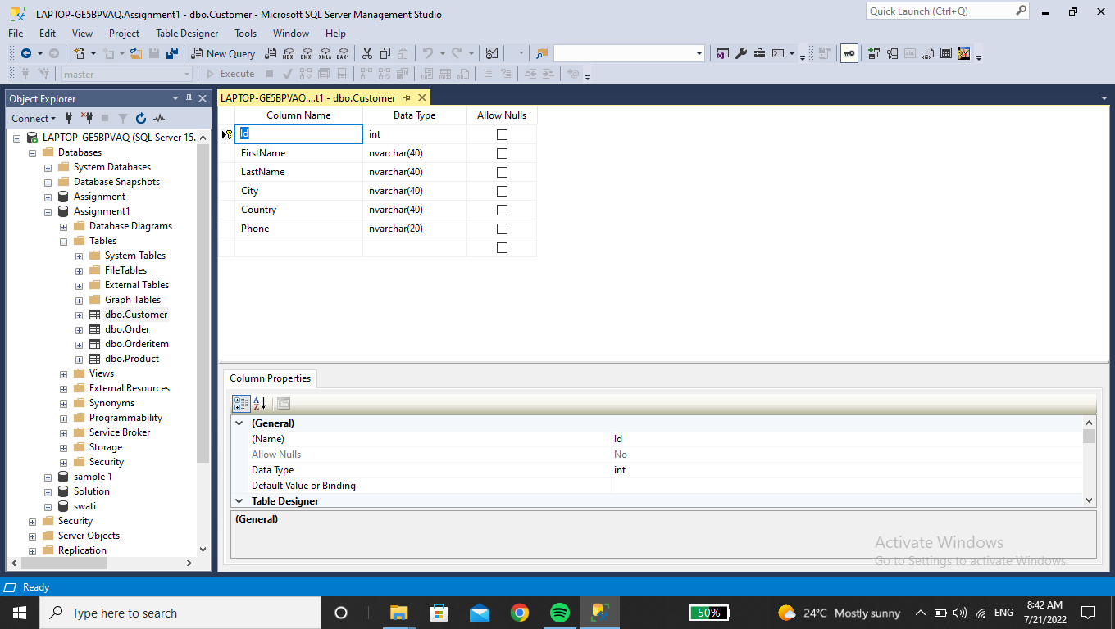

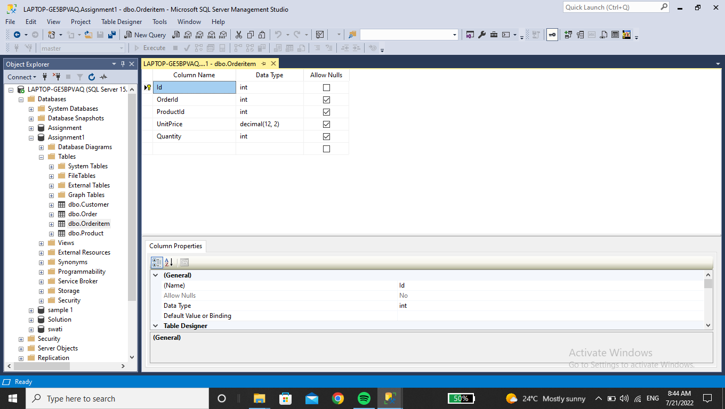

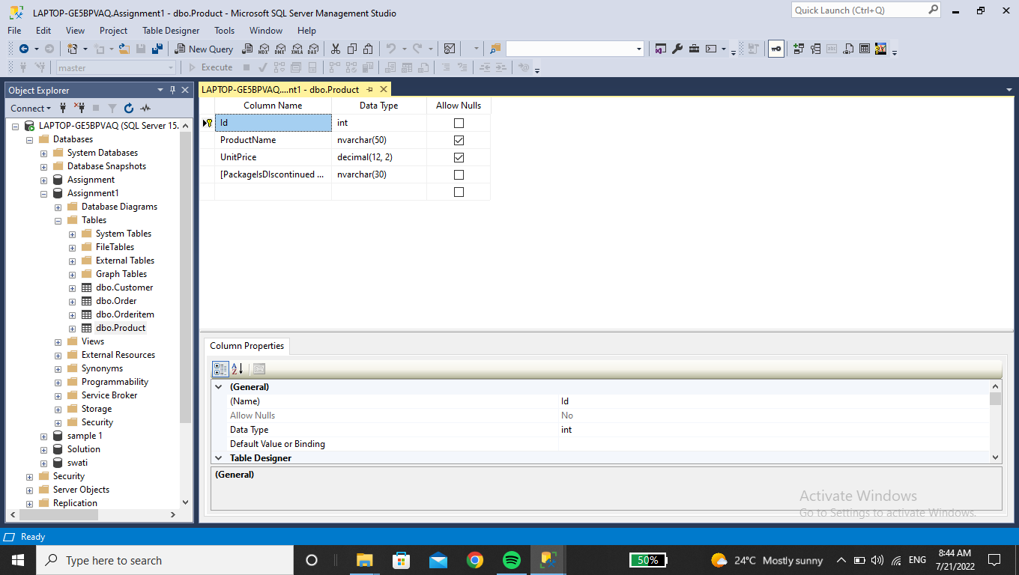

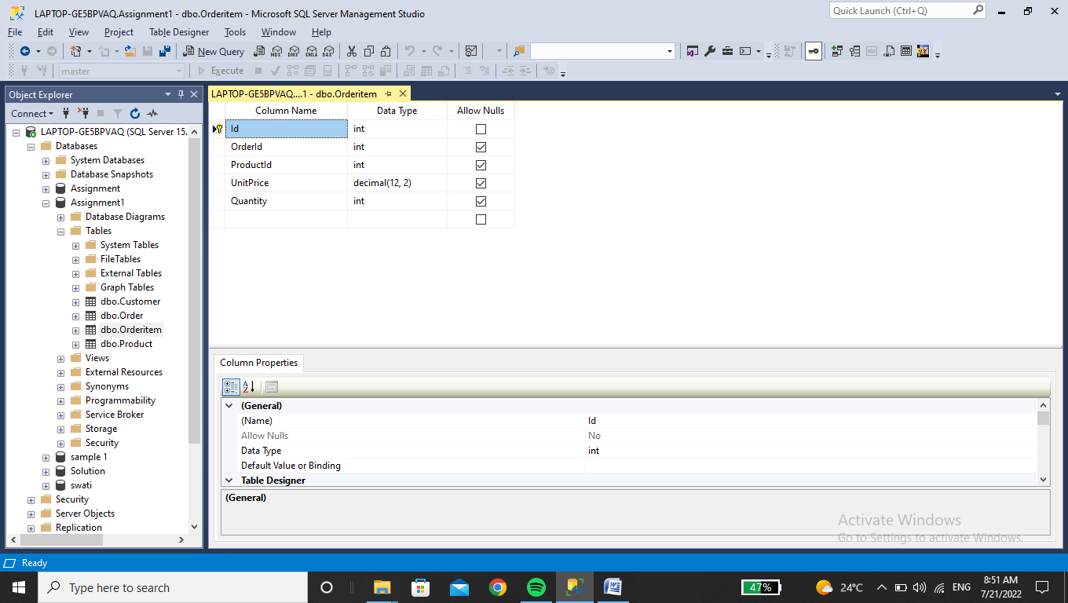

1. Insert Records in all tables.

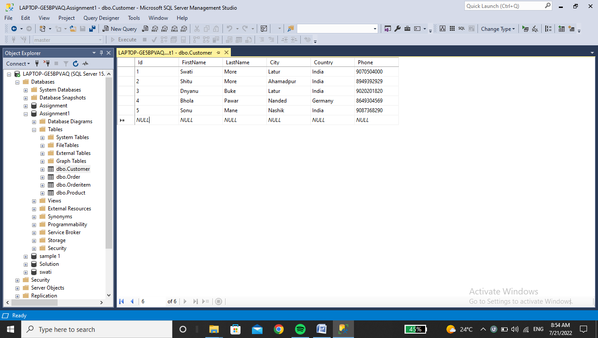

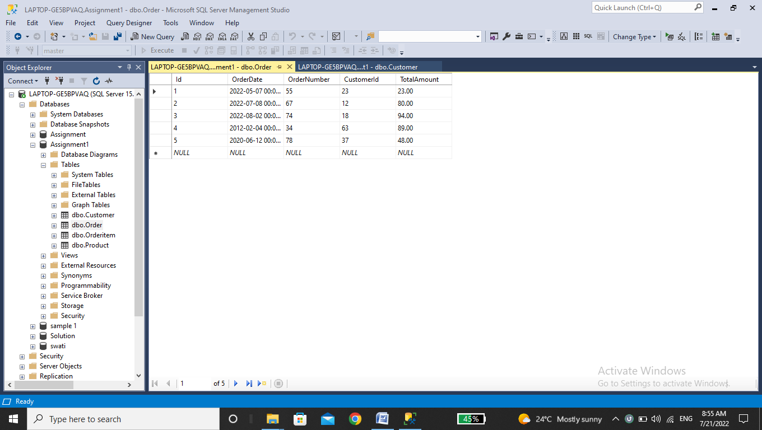

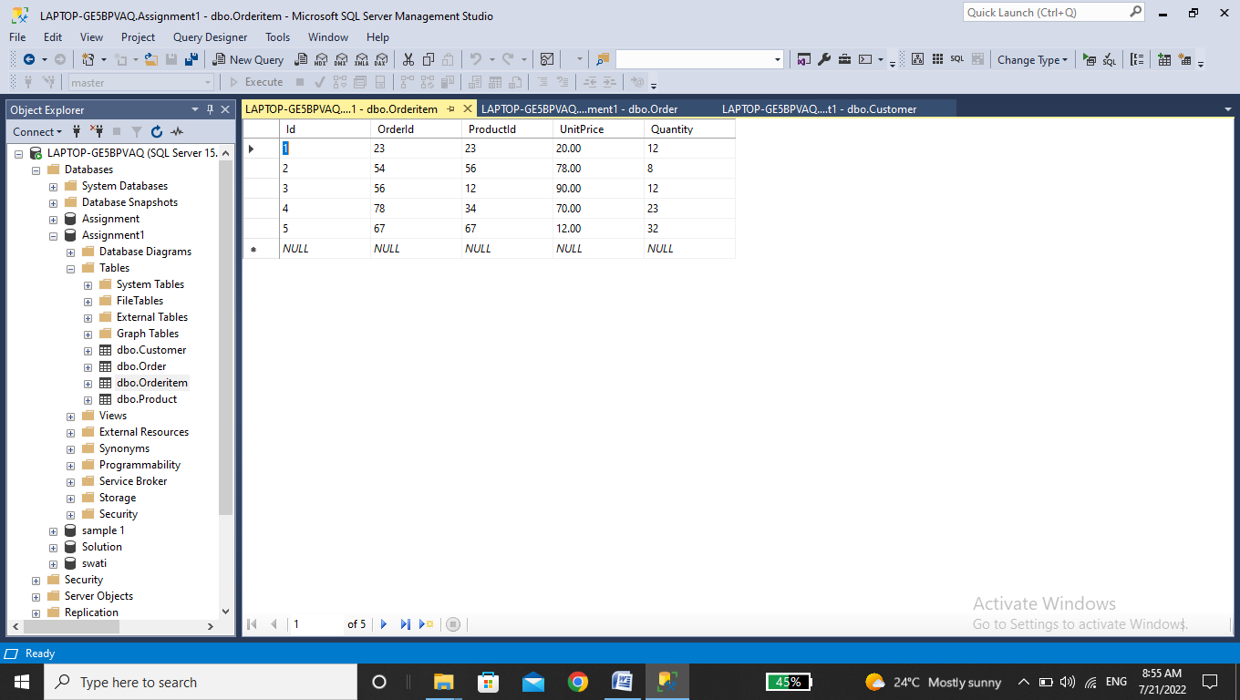

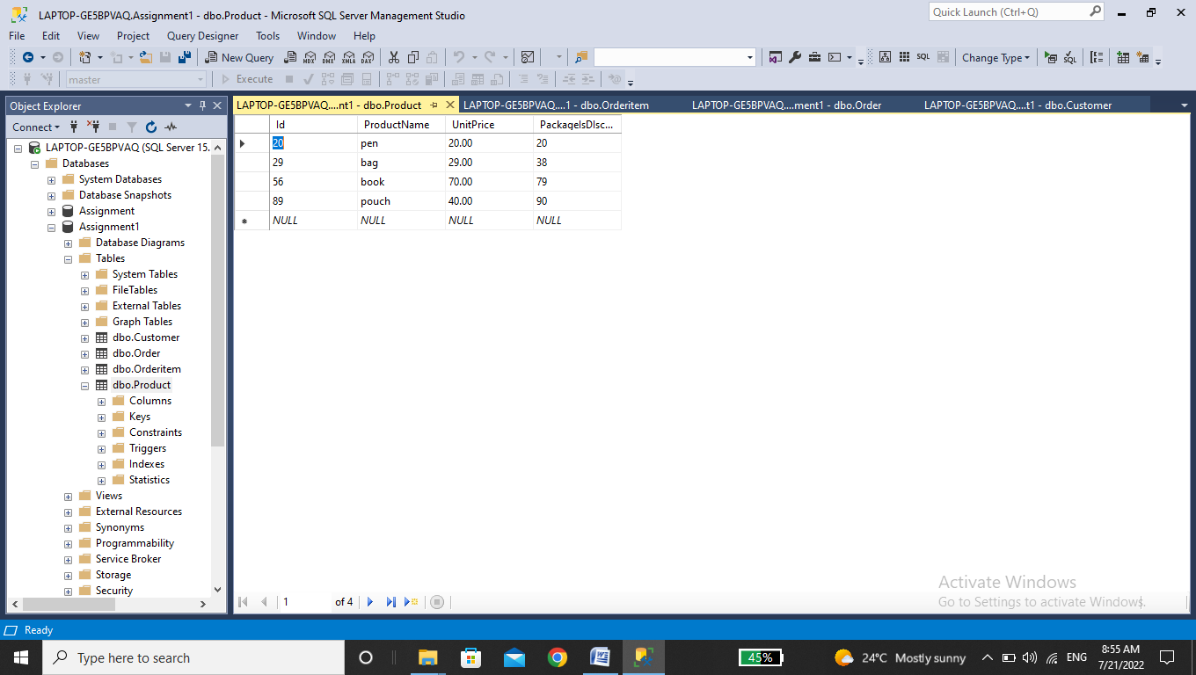

1. In customer Table FirstName attribute should not accept null value.

SELECT * From dbo.Customer WHERE FirstName != NULL;

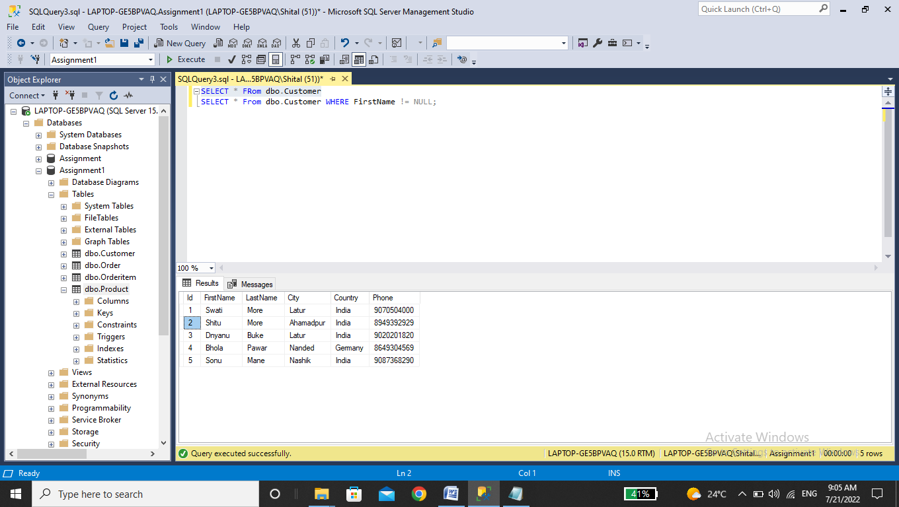

1. In order table OrderDate should not accept null value.

SELECT * From dbo.Orderitem WHERE OrderDate != NUll;

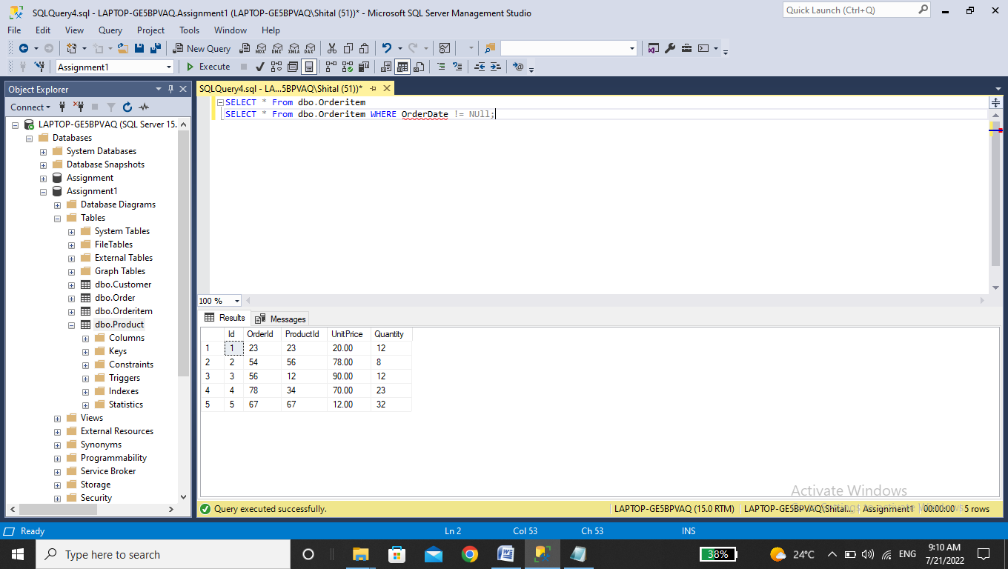

1. Display all customer details.

SELECT * From dbo.Customer;

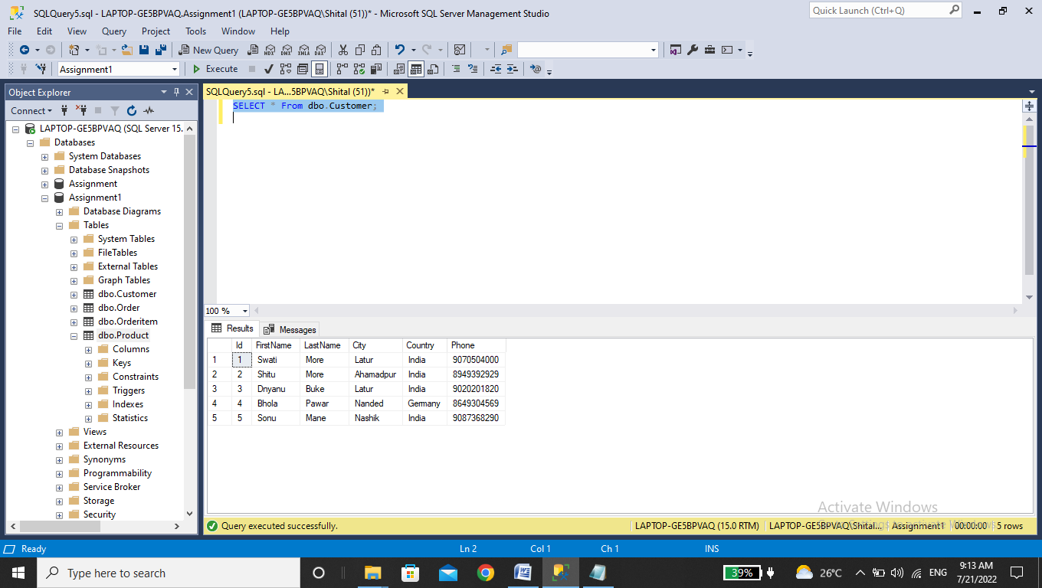

1. Write a query to display country whose name starts with A or I.

SELECT Country From dbo.Customer WHERE Country LIKE'I%';

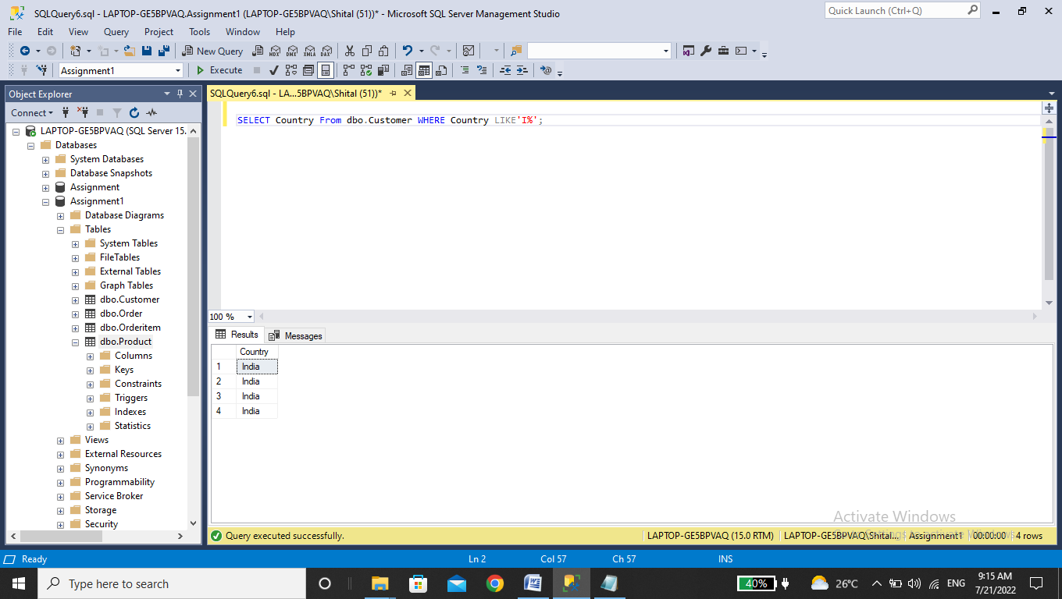

7.write a query to display whose name of customer whose third characters is i.

SELECT FirstName,LastName From dbo.Customer WHERE FirstName LIKE'__I%';

